Statistical Analysis of the UCI Adult Income Dataset Using Python

1. Introduction and Dataset Description
In this report, I used the Adult Income dataset from the UCI Machine Learning Repository to carry out statistical analysis using Python. The main aim of this analysis is to understand the dataset and explore how factors such as age, education and weekly working hours are related to income.
The dataset contains both numerical and categorical variables. After checking the data and removing rows with missing values, 30,162 rows remained. The numerical variables include age, education-num, capital-gain, capital-loss and hours-per-week. The categorical variables include education, occupation, sex and income.
I used descriptive statistics and different graphs to understand the data and identify patterns. I also used Binomial, Poisson and Normal distributions to analyse probabilities and compare the distributions of selected variables.

2. Descriptive Statistics and Data Visualisation
I used Python to analyse the numerical and categorical variables in the dataset. I calculated descriptive statistics such as the mean, median, mode and standard deviation for the numerical variables. I also created different graphs to understand the distribution of the data and compare the variables.
Age
The mean age is 38.44 years, the median is 37 years and the standard deviation is 13.13 years. The ages range from 17 to 90 years. The age distribution graph shows that the distribution is right-skewed. This means that most individuals are young or middle-aged, while older individuals make up a smaller proportion of the dataset.
Hours per Week
The average number of working hours per week is 40.93, with a median of 40 and a standard deviation of 11.98. The boxplot shows that many individuals work around 40 hours per week. However, some individuals work significantly fewer or more hours than others and the extreme values appear as outliers in the graph.
Education and Income
The graph comparing education and income shows how the number of individuals in the higher and lower income categories differs across education levels. However, we cannot conclude from the number of individuals alone that higher education increases the probability of earning a higher income. This is because the total number of individuals in each education group is different.
Income Distribution
Approximately 75.1% of individuals in the dataset earn $50,000 or less per year, while 24.9% earn more than $50,000. This shows that the two income categories are not equally distributed, with more individuals belonging to the lower-income group.

3. Binomial Distribution
In this section, I used the Binomial Distribution to calculate the probability of individuals earning more than $50,000 per year. Using Python, I calculated that the probability of an individual earning more than $50,000 is 0.249, or 24.9%. Based on this result, I used the Binomial Distribution to calculate how many people out of a sample of 20 might earn a higher income.
Mathematical Calculation
The Binomial probability formula is:
$$P\left(X=k\right)=\left({n \atop k}\right)p^{k}{\left(1-p\right)}^{n-k}$$
Where n is the sample size, k is the number of individuals earning more than $50,000, and p is the probability of earning more than $50,000.
For this analysis:
$$X∼Binomial\left(n=20,p=0.249\right)$$
The expected value is calculated as:
$$E\left(X\right)=np=20×0.249=4.98$$
This means that, on average, approximately 5 out of 20 individuals would be expected to earn more than $50,000 per year. The Binomial Distribution graph shows that the most likely number of higher-income individuals is around 5. The probability of having a much smaller or larger number of higher-income individuals is relatively low. I also compared the distributions using sample sizes of 20, 100 and 300. As the sample size increases, the expected number of higher-income individuals also increases. For example, the expected number is 24.9 out of 100 people and 74.7 out of 300 people. As the sample size becomes larger, the shape of the Binomial Distribution can become more similar to a Normal Distribution. This calculation assumes that individuals are selected independently and randomly, with the same probability of earning a higher income. However, in reality, this probability may differ depending on factors such as age, education and occupation.
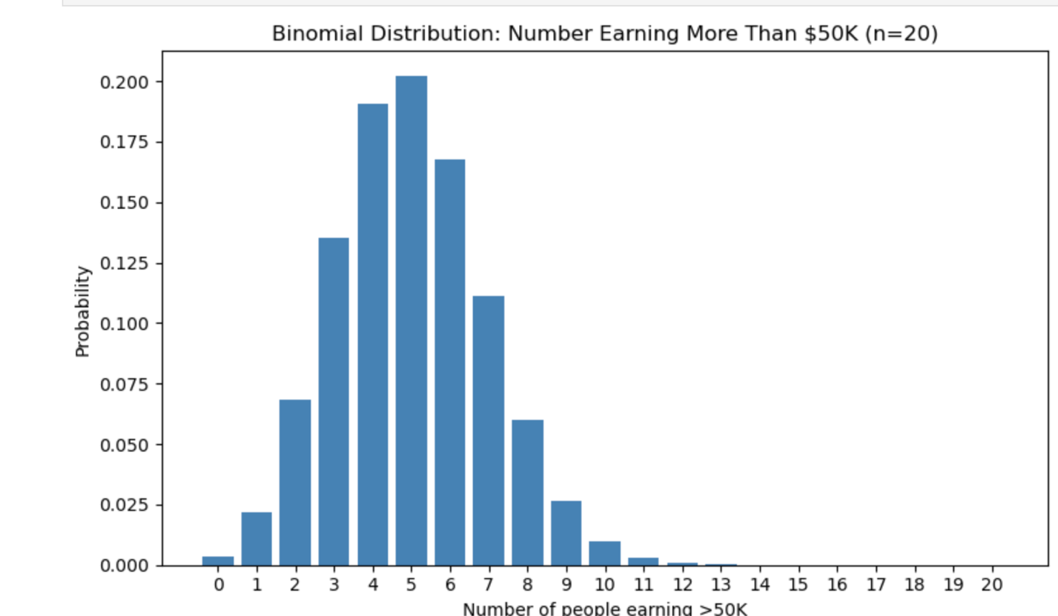
4. Poisson Distribution
In this section, I used the Poisson Distribution to calculate the number of individuals with a capital gain greater than zero in a group of 20 people.
Using Python, I calculated that the probability of an individual having a capital gain greater than zero is 0.084, or 8.4%. Based on this probability, I calculated the expected number of individuals with a positive capital gain in a group of 20.
Mathematical Calculation
The Poisson Distribution formula is:
$$P\left(X=k\right)=\frac{e^{-λ}λ^{k}}{k!}$$
Where λ is the expected number of individuals and k is the number of individuals with a positive capital gain.
$$λ=np=20×0.084=1.68$$
This means that, on average, approximately 1–2 individuals out of 20 would be expected to have a capital gain greater than zero.

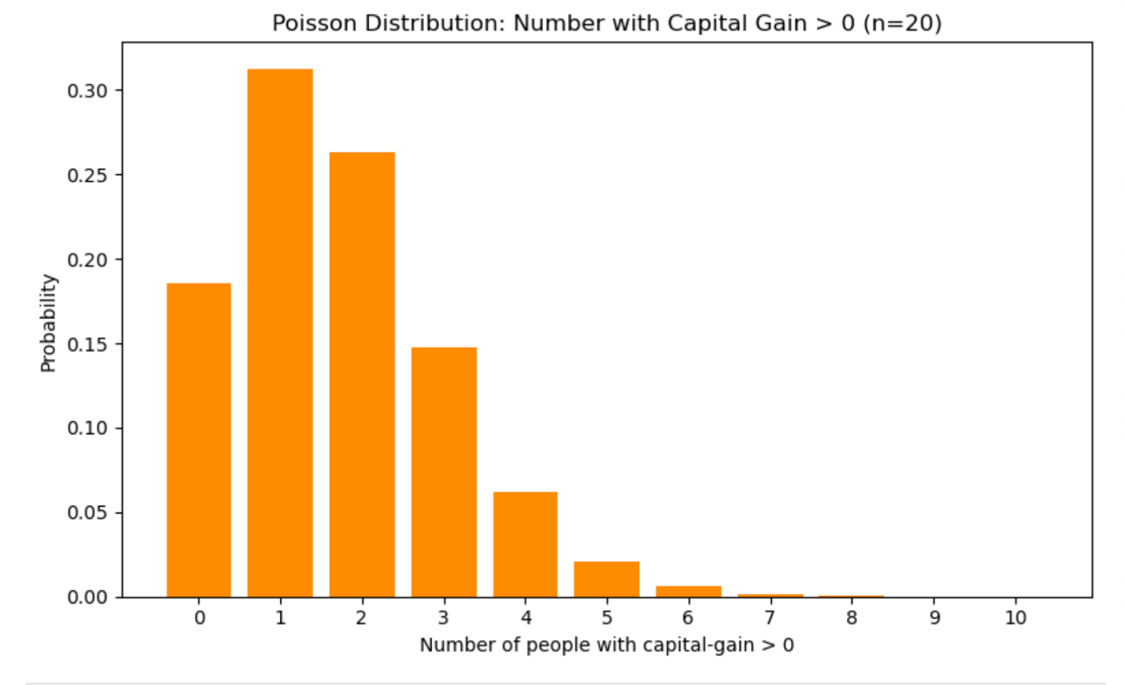
The Poisson Distribution graph shows that the probability of 1 or 2 individuals having a positive capital gain is relatively high, while the probability of a larger number of individuals decreases. I used the Poisson Distribution as an approximation of the Binomial Distribution because the probability of having a capital gain greater than zero is relatively low. However, the two distributions do not give exactly the same results. I also compared the Binomial and Poisson Distributions using sample sizes of 20, 100 and 300. As the sample size increases, the expected number of individuals with a positive capital gain also increases. For example, the expected number increases from 1.68 for 20 people to 8.4 for 100 people and 25.2 for 300 people. However, the probability of an individual having a positive capital gain remains at 0.084. Therefore, increasing the sample size does not necessarily make the Poisson approximation more accurate.
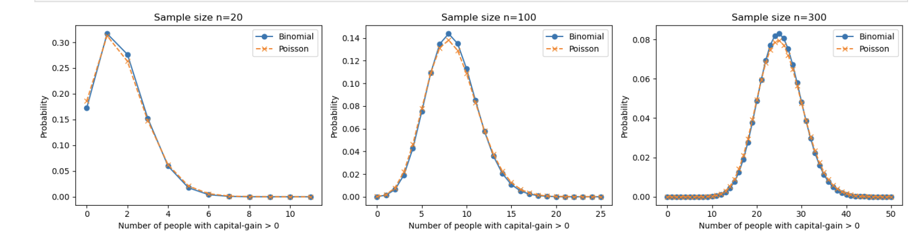

5. Normal Distribution
In this section, I used the Normal Distribution to analyse the age distribution of individuals in the dataset. I selected age because it is a numerical variable with a wide range of values, making it suitable for comparison with a Normal Distribution. Using Python, I calculated that the mean age is 38.44 years and the standard deviation is 13.13 years. I used these values to compare the actual age distribution with a theoretical Normal Distribution curve.
Mathematical Calculation
The Normal Distribution model for age is:
$$X∼N\left(μ=38.44,σ^{2}={13.13}^{2}\right)$$
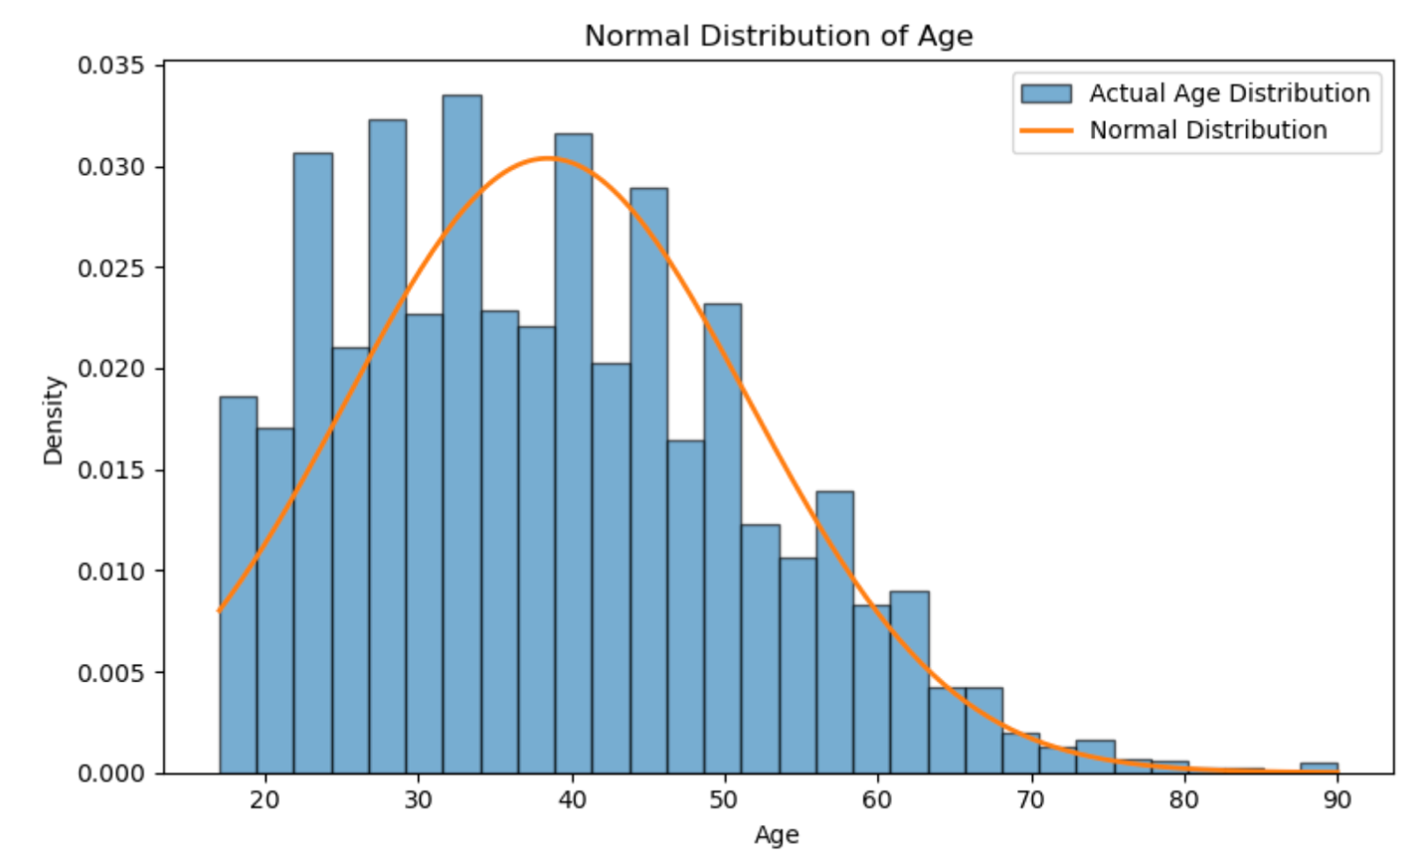
The comparison between the age histogram and the Normal Distribution curve shows that the actual data does not perfectly follow a Normal Distribution. Most individuals are young or middle-aged, and the age distribution is right-skewed. This shows that the Normal Distribution can be used to compare the age data, but it does not fully represent the actual distribution.

6. Discussion and Justification
In this analysis, I used Binomial, Poisson and Normal Distributions. These distributions help to understand different characteristics of the data and calculate probabilities.
I used the Binomial Distribution to calculate the number of individuals earning more than $50,000 per year. This is because there are two possible outcomes: an individual either earns more than $50,000 or does not.
I used the Poisson Distribution to model the number of individuals with a positive capital gain. I selected it as an approximation of the Binomial Distribution because the probability of having a positive capital gain is relatively low.
I used the Normal Distribution to analyse the age distribution. Age is a numerical variable, and its actual distribution can be compared with a theoretical Normal Distribution.
Binomial and Poisson are discrete distributions, which model outcomes that can be counted using whole numbers. In contrast, the Normal Distribution is a continuous distribution.
In some cases, discrete variables can be approximated using a Normal Distribution. For example, when the sample size is sufficiently large and both np and n(1-p) are large enough, the Binomial Distribution can become similar to a Normal Distribution. However, not all discrete variables can be modelled using a Normal Distribution. Choosing the appropriate distribution is important for interpreting the data and understanding the results correctly.

7. Conclusion
In this study, I used the UCI Adult Income dataset to perform statistical analysis using Python. I used descriptive statistics and graphs to examine different variables, including age, education, working hours per week and income. The results showed that the average age of individuals in the dataset was 38.44 years, and the average working hours per week was 40.93 hours. I also found that 75.1% of individuals earned $50,000 or less per year, while 24.9% earned more than $50,000. I used the Binomial Distribution to model the number of individuals with higher incomes and the Poisson Distribution to model the number of individuals with positive capital gains. I also used the Normal Distribution to compare the actual age distribution with a theoretical Normal Distribution. These analyses helped me understand the distribution of the data, identify differences between variables and learn how probability models can be applied to real-world data. However, these distributions are based on certain assumptions, so they may not always fully represent the actual data.

Reference
Becker, B. and Kohavi, R. (1996) Adult [Dataset]. UCI Machine Learning Repository. Available at: https://doi.org/10.24432/C5XW20 (Accessed: 2 November 2026).

